ConvNet Playground: An Interactive Visualization Tool for Exploring Convolutional Neural Networks

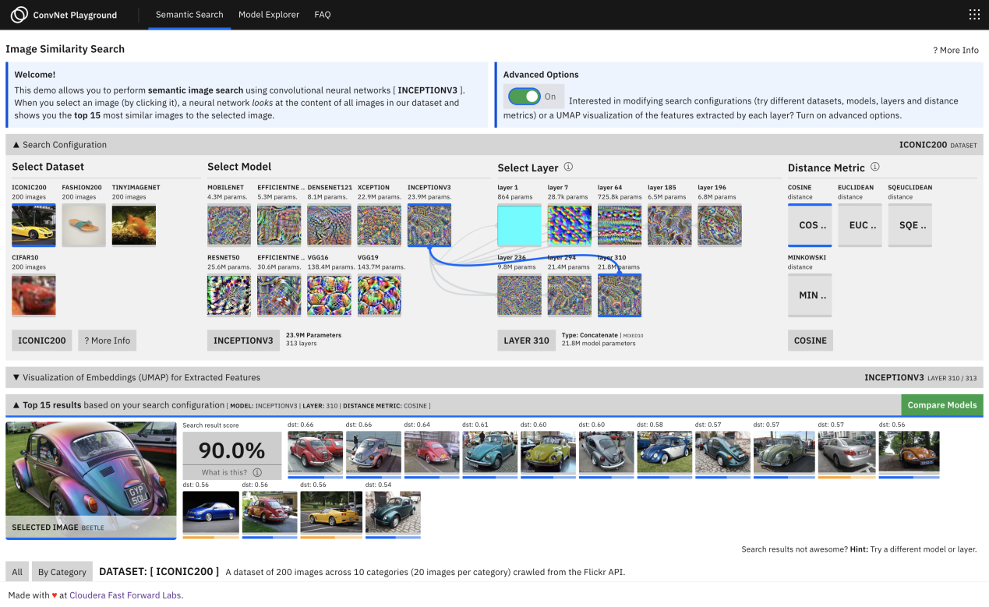

[ConvNet Playground](https://convnetplayground.fastforwardlabs.com/#/) is an interactive visualization for exploring Convolutional Neural Networks applied to the task of semantic image search.

It allows you to explore the performance of multiple pre-trained CNN architectures (and intermediate models based on each architecture) for feature extraction on images across various datasets.

Go ahead and explore more about it, [here](https://convnetplayground.fastforwardlabs.com/#/) :